**EXPN08: CREATE A VIRTUAL HARDDISK**

**AIM:** Create a Virtual Hard Disk and allocate the storage using virtual box.

**Material:**

● VM Workstation software.

● Configurations.

**Procedure:**

**Step 1:**

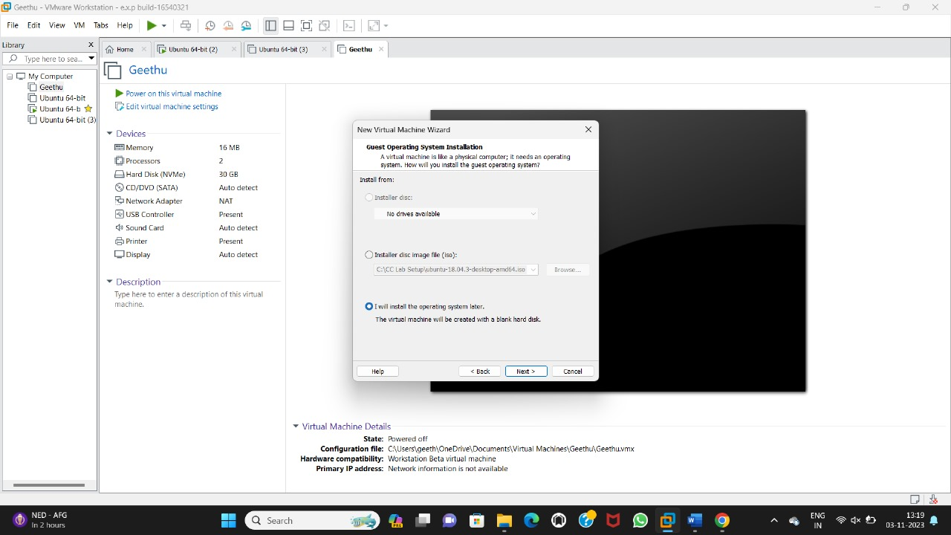

**Step 2:**

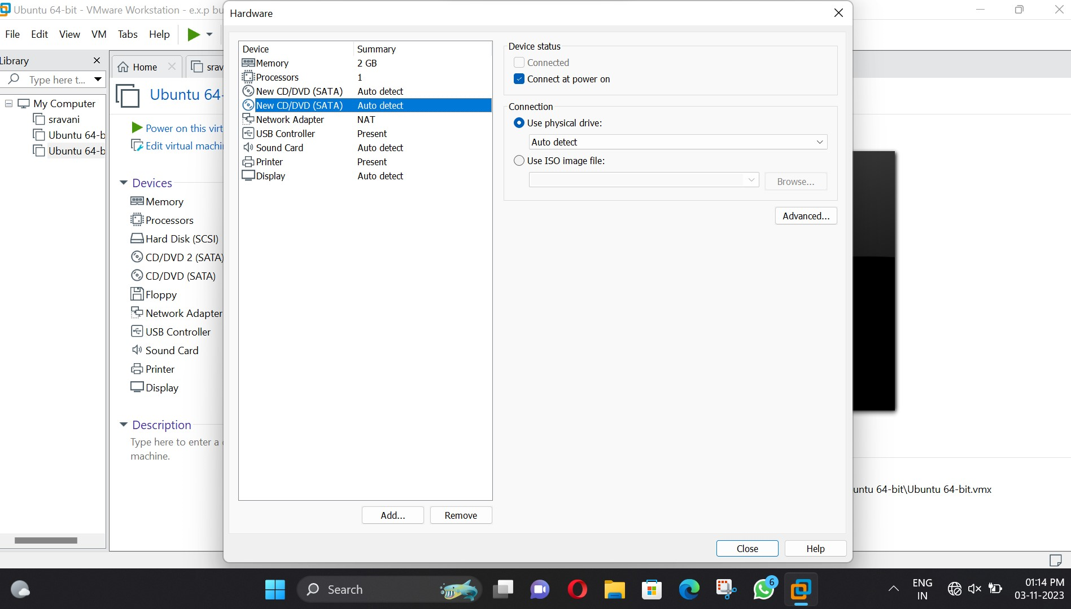

**Step 3:**

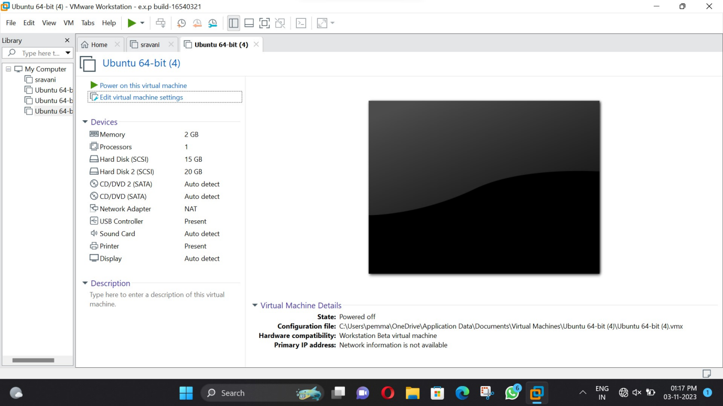

**Result:**

Successfully configure VM image with a Virtual Hard Disk and allocate the storage using virtual box.